Tech Guide - 2026 DEVO CROSS
Hosted by Devo Escape Velocity
October 25, 2026
Event Location: Inter River Park, North Vancouver
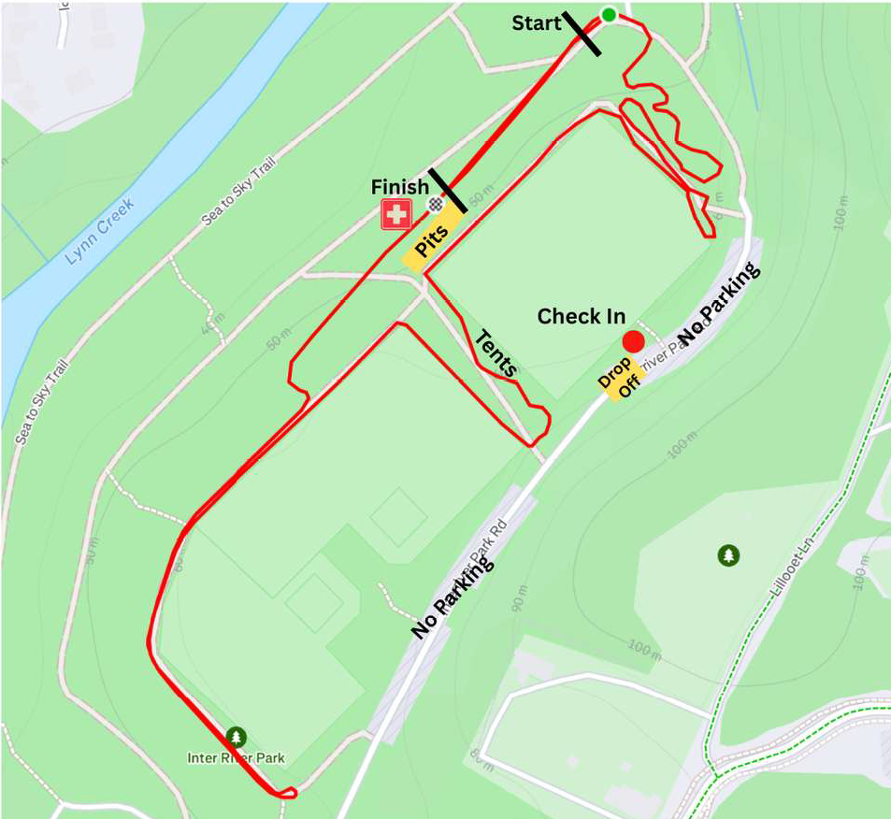
Course direction is CCW. The organizer reserves the right to revise or “improve” the course.

Emergency Action Plan
DEVO CX 2026
In the event of an incident requiring medical attention or assistance, please utilize the following.
Race Director: Teresa Rossiello 604-790-4562
Chief of Course: Andrew Pinfold 778-839-5275
Alternate: Anselmo Rossiello 604-612-2902
First Aid Attendant: Eric Vermander 604-910-8243
Call Person: Eric Vermander 604-910-8243
First Aid Station: Located at First Aid Tent near Start / Finish area
Local Emergency Services: Call 911
Nearest Hospital: Lions Gate
231 East 15th Street North Vancouver

Provincial Health Orders
In the event there are any Provincial Health Orders in place at the time of the event, we will arrange to implement and take any and all requirements to heart.
We must and will conform to any new or revised Provincial orders.
Additional requirements:
All our activities will be outdoors. We request you be respectful of others, regardless of their fears or actions.
There will be no organized food or drink provided to race participants or guests. All riders must bring their own food and drinks.
On Site Parking
Please remember that we share the park with dog walkers and soccer players, so let’s all do our part to reduce congestion. To help limit parking needs, please ride your bike or carpool whenever possible.
Parking is available in the BMX track lot. After you park, please ride up to the check-in and registration area.
Garbage
Yes, Trash Talk.
Please, if you pack it in, pack it out. Please treat the park as you own, it is.
Please also pass on this message to any guests you bring to the races.
Sponsorship For Event
We need to offer up thanks to all our volunteers and sponsors for assisting with management of equipment, support and prizes for our event. Their contribution is crucial and most appreciated.
REGISTRATION
Sign on and registration will open at 9:00 am
Registration will be On-Line through Uplifter (formerly CCN). There is Race-Day or on-site reg for $60.00 for adults. Square will be available or Cash exact amount is preferred. Closes 1 hour prior to race start.
You must have a Cycling BC license and will be asked to show it.
We want to do all we can to encourage on-line registration prior to Race Day.
Regardless of how creative your excuse is, Race-Day reg will not get you on the call-up list. Just remember how much fun it is starting at the back and working your way up.
The cut-off for on-line Reg is 7:00 PM on October 24, 2026.
Course
The course will open at 9:30 am
Pre-riding is permitted between races as per the race schedule, but racers can only enter the course at the designated point behind the finish line.
There will be an announcement to indicate when the course is open; be mindful of any racers on course.
Team Alley
There will be a designated Team Zone for tents. Along the south fence of Field #8
If your team/club is bringing a tent, please email cx-mtb-race@escapevelocity.bc.ca to reserve ONE parking spot near the course.

Feed Zones and Mechanical Support
Feeding is allowed on the course.
We plan to have neutral mechanical support from Ed at MIGHTY Bikes
There will be a designated pit zone.
If you DNF (Do Not Finish), please report to the Commissioners at the timing tent and inform them.
Bonus for the hardy, the misguided and those wanting more.
If you have the want or need to race in two categories, your second entry is $5.00.
This means that those BASS racers or anyone else who can fit it in, can get in a little more action if they want. This is available for all the adult race categories. Just make sure you meet the criteria for entry in each group. Eg. You could do Men’s Launch and Men’s Masters, or SS and Elite, Masters or ..?
Timing Numbers and Pins.
Good news, we are back to a previously loved Timing Chip System. RFID Tags will be issued to racers. If you have any old ones, bring them and they can be checked to see if they are useable. If you need a new tag, they may be $5.00 each. Good news, if you look after them, they can be used at subsequent events. Make sure they are securely mounted to your seat post and for Pit-Bikes, bring your second tag to Reg.
If you have pins, bring them. Just in case … The alternative is Duct Tape.
Numbers … DO NOT LOOSE THEM. They will be re-used at other events in 2026. Once you have your number, the plan is to keep that for the series.
Save your number and timing chip, DO NOT Leave Home without it.
INTER RIVER PARK PROTOCOLS:
Racers … Helmets MUST be worn any time you are riding a bike. Only exception is on trainers or rollers. Repeated violation will result in disqualification.
RACE CATEGORIES
Open Men’s Categories
- Elite (Advanced)
- Masters 40+
- Super Master 55+
- Intermediate
- Launch (formerly Novice or Beginner)
- Single-Speed
- Youth: U19, U17, U15, U13
- Non-Binary
Women’s Categories
- Elite (Advanced)
- Masters 40+
- Intermediate
- Launch (formerly Novice)
- Youth: U19, U17, U15, U13

CATEGORIES DEFINITIONS
Since Cyclo-Cross World Championships are in February 2027, rider ages are based on rider’s age as of December 31, 2027. It may not seem logical, but that is how it works.
For LMCX events, BC Provincials and Nationals, this age criteria will apply to Youths and Masters racers.
Younglings
- 1 full or partial lap on the main adult course
- Any non-electric bike is allowed
- Once riders feel comfortable at the distance and pace, it is recommended that they try Launch
Launch (Novice)
- Riders that are new to bike racing, cross racing, trying their first sports events or just getting back into competition
- Equivalent to racing Cat 4/5 on the road
- As with all our categories if you are too fast, we will give you a gentle nudge
- U13/U15 riders will race in this category unless they are high performance and choose to race Intermediate or Elite.
  - Licenced riders who are under the race ages of 13 or 15 respectively (age as of Dec 31, 2027)
  - There are no U13/U15 podiums or prizing.
  - Boys and Girls will start in the Novice field of their respective gender category
  - Riders may choose to start near the front, back, or middle of the field, as per their coach’s recommendation. Typically, very young or new riders will start at the back of the field. It is way more fun to be passing than to be getting passed. Starting at the back is nothing to be ashamed or afraid of.

Intermediate
- Riders that have graduated from Launch. Faster but not quite fast enough to race Elite
- Equivalent to racing Cat 3/4/5 on the road
- Racer age, over 40 you should race Masters
- U17 riders will race in this category unless they are high performance and choose to race Elite
Masters
- Masters riders must have a racing age of 40 or older (age as of Dec 31, 2027)
- Super Masters 55+ is open to any racers 55 or older. This is a voluntary class, if you are over 55 and wish to race in another class, good on you.
- If you are crushing your race-mates we encourage you to race in Elite
Elite
- Too fast for Intermediate, upgraded from Intermediate, or have finished in the top half of the Intermediate field consistently
- Riders holding a Cat 1/2 road license, but this is not a requirement.
- Racers age 40+ can race Masters or Elite if they so desire. There is no requirement to be licensed as an Elite in order to race as an Elite in a Grassroots 100+ event.
- Elite category is also open to Juniors …. If you think you are fast enough “just do-it”. But be warned, the race will be 60+ minutes. Even more fun.
Single Speed
- Open to all ages and abilities

Non-Binary

- This open-ability category is for non-binary, gender-queer, agender, and gender-transcendent athletes who want a welcoming, competitive space on the course. If numbers are small, ya’ll will have the option of joining the start of the Open Launch race so you have more folks to compete with

KinderCross

- For kids aged 2-8 (approximately) there will be a mini-race course set up as well as some gentle “Hop On” instruction provided on site at 11am. Around 12:15 we will host a wave of short races for the kids, based on laps they would be able to complete, roughly guided by their ages and abilities.

Hub’s Kids On Wheels

- Hub will host a Kids On Wheels Balance bike camp from 10-12, funded from a Cycling Canada grant. They will have loaner balance bikes and various skills and games set up. No registration is required, just show up!

PRIZING
Elite Open / Elite Women
Elite Open & Elite Women will receive equal day-of cash prizing as follows:
1st | 2nd | 3rd | 4th | 5th
$100 | $80 | $60 | $40 | $20
Other Classifications:
Podiums will be arranged following races and the top 3 in each group will be honored. Under the current climate, it has been “challenging” to arrange prizing and it may not be possible to reward all in the way that we would like.
Separate u13/15 (Women and Men) podium and if they place in the top 3 overall in launch they would have a 2nd podium.
For youth that race intermediate or open waves they will be included in the overall podium.

Start Order Procedure
Combined categories will have separate starts when possible. If they race as one group, they will be scored separately.
Call-ups for will be by series standings.
As mentioned earlier, if you didn’t register in advance, not likely you will benefit from a call-up.
Overall Series Standings:
- Series standing will be scored for all categories and will be posted on the LMCX web site.
https://lmcx.ca/

- All races in the series count toward the overall series standings
- The final race of the year is scored for points in the same way as all other races
- Every race counts – no placings are dropped
Series Points Table
Yes, there is going to be a Lower Mainland CX Series, (LMCX) for 2026. There will be a table created showing who came where in what and the points they earned.
Points are awarded based on the following …. With luck, we will have a soiree at the end of the season to toast and award the winners. November 20th. Details available on LMCX web site.
1st through 25th places
1st | 2nd | 3rd | 4th | 5th | 6th | 7th | 8th | 9th | 10th
32 | 29 | 26 | 23 | 21 | 20 | 19 | 18 | 17 | 16
11th | 12th | 13th | 14th | 15th | 16th | 17th | 18th | 19th | 20th
15 | 14 | 13 | 12 | 11 | 10 | 9 | 8 | 7 | 6
21st | 22nd | 23rd | 24th | 25th
5 | 4 | 3 | 2 | 1
Ties will be broken by greatest number of wins, or, if still tied, by the placing in the final race.
If that doesn’t do the job, Rock Paper Scissors, best 2 out of 3 wins it.

RULES/PROCEDURES
Licensing
- A Cycling For All license is sufficient for all categories. If you have that or other advanced Cycling BC license you are good to go. If not, you may purchase a Single Event License for $15 dollars up to 3 times per year.
- Foreign / Out of Province: Riders with a UCI International license are welcome to race the category listed on their license (All other Riders - one day event insurance is available)
Bike Requirements
- Launch / Novice: Gravel, Mountain and Hybrid bikes are allowed for Novice races though Cyclocross bikes are recommended (Yes Fat Bikes are allowed in the Novice classes)
- Juniors/Intermediate/Masters: Cyclocross (or Gravel) bikes are highly recommended for Intermediate and Master races, but Mountain Bikes are permitted. (Yes, Fat Bikes allowed)
- Elite: Elite races will be subject to UCI rules regarding equipment. Yes, No Fat Bikes.
- Single Speed: Bikes must be limited to one gear (if it only has one gear, it is allowed)
- Did we mention: No E Bikes.

RACE DAY SCHEDULE
Start Times and Race Duration -Start Times are subject to change if delays occur
Racers should be in the staging area 10 minutes prior to the start of their race

Race | Categories | Start | Duration
Course Open - 9:30a | Course Open for Practice | 9:30 | 60 min
Launch Wave - 10:15a | Open Singlespeed and Tracklocross | 10:15 | 30 min
 | Non-Binary | 10:16 | 30 min
 | Open: Beginner / Launch / U13 / U15 | 10:17 | 30 min
 | Women: Launch / U13 / U15 | 10:18 | 30 min
Intermediate Wave - 11:15a | Open: Intermediate / U17 | 11:15 | 45 min
 | Women: Masters (40+) | 11:16 | 45 min
 | Women: Intermediate / U17 | 11:16 | 45 min
Intermission - 12:15p | Intro Ride / Party Lap: One Lap (all bike types and skill levels welcome) | 12:15 | ~12 min
 | Younglings - Partial Course | 12:17
 | KinderCross (various times - see Kids Race Schedule) | 12:20
 | Course Open for Practice | 12:30 | 45 min
 | Podiums for Launch Wave and Intermediate Wave | 12:45
Masters Wave - 1:15p | Open: Masters (40+) | 13:15 | 45 min
 | Open: Super Masters (55+) | 13:16 | 45 min
Elite Wave - 2:15p | Open: Advanced / U19 | 14:15 | 60 min
 | Women: Advanced / U19 | 14:16 | 50 min
Course Teardown - 3:15p | All hands on deck - help us clear the park | 15:15
 | Podiums for Masters Wave and Elite Wave, Draw Prizes | 15:30

Kids Events: Vanier (See category guide above for more details)
 | KinderCross Kids Event Schedule (Trout CX & Vanier)
10:00 AM -12:00 PM | Kids on Wheels Balance Bike Clinic (p/b HUB Cycling)
12:17 PM | Younglings - Partial Lap Main Course
12:20 PM | KinderCross Race #1 (Age 2-4)
12:25 PM | KinderCross Race #2 (Age 5-6)
12:30 PM | KinderCross Race #3 (Age 7-8)

